**FADE IN FADE OUT OF LED USING 8051 USING PROTEUS**

**AIM:**

To write an assembly language program for Fade in Fade out of LED Using 8051 using Keil and Proteus.

**SOFTWARE REQUIRED:**

* Proteus 8 software.

**PROGRAM:**

ORG 00H ; Start program at address 00H

MAIN: MOV P2, #00H ; Initialize Port 2 (LED off)

ACALL FADE_IN ; Call Fade In subroutine

ACALL FADE_OUT ; Call Fade Out subroutine

SJMP MAIN ; Repeat forever

; Subroutine to Fade In the LED

FADE_IN:

MOV R0, #00H ; Start with 0% duty cycle (LED off)

FADE_IN_LOOP:

ACALL PWM ; Call the PWM subroutine with the current duty cycle

INC R0 ; Increase the duty cycle

CJNE R0, #FFH, FADE_IN_LOOP ; Repeat until max brightness (100% duty cycle)

RET

; Subroutine to Fade Out the LED

FADE_OUT:

MOV R0, #FFH ; Start with 100% duty cycle (LED on)

FADE_OUT_LOOP:

ACALL PWM ; Call the PWM subroutine with the current duty cycle

DEC R0 ; Decrease the duty cycle

CJNE R0, #00H, FADE_OUT_LOOP ; Repeat until min brightness (0% duty cycle)

RET

; PWM subroutine

PWM:

MOV A, R0 ; Load duty cycle value

MOV B, #FFH ; Set maximum period

MOV P1, #00H ; LED ON (active-low, so writing 0 turns on the LED)

PWM_ON_LOOP:

DJNZ A, PWM_ON_LOOP ; Delay based on duty cycle (LED ON time)

MOV P1, #01H ; LED OFF

PWM_OFF_LOOP:

DJNZ B, PWM_OFF_LOOP ; Delay for the rest of the period (LED OFF time)

RET ; Return from subroutine

END

**CIRCUIT DIAGRAM:**

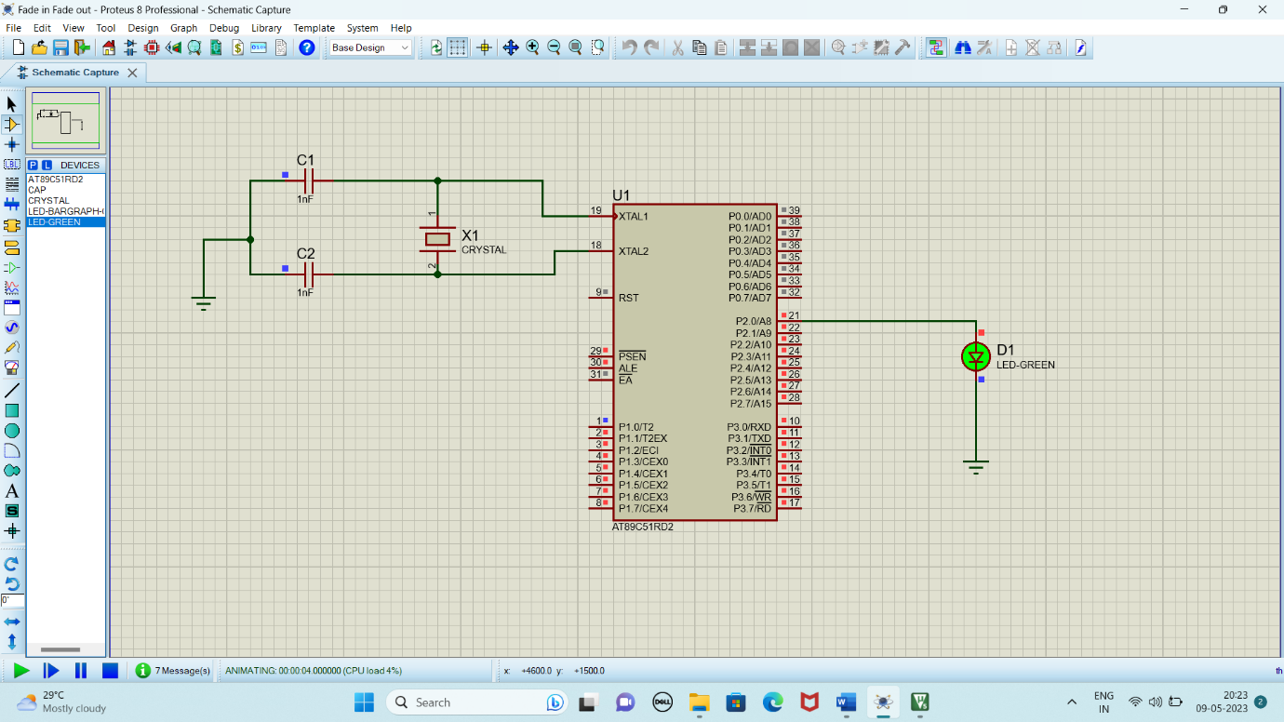

**OUTPUT:**

The brightness of the LED is gradually increasing and decreasing with 1000ms delay.

**RESULT:**

Thus, the program has been successfully verified and executed